Oracle Education Foundation

**Hello, World!**

October 2018

Car Assembly Video

**Supplemental Instructions**

When you’re ready to build your car, open the instructional video saved on your computer. For the most part, you can simply copy the steps taken in the video and use this document to help clarify or supplement the instructions in the video.

**However, there are a few steps we are doing differently than they do, which are noted in bold. Keep an eye out for the bold timestamps as you work, and be sure to follow the instructions here rather than the video at those points.**

|  |  |  |
| --- | --- | --- |
| **Time** | **Component** | **Step (& Notes)** |
| 00:10 | Arduino | Attach risers |
| Attach to board   * Check orientation of your board * Use only two screws to attach Arduino to board |
| **01:20** | Front Wheels | Attach yellow DC motors to board   * **No need to peel off the liner** * Wires face inward |
| 03:25 | Back Wheel | Attach risers |
| Attach to board |
| 05:20 | Motor Driver | Attach risers (with nuts) |
| **Skip 6:10 --> 6:40** | | |
| 06:40 | Servo Platform | Attach risers |
| **07:20** | Battery Pack | Attach to board   * **Note ours is 6-pack rather than 4-pack** * **Pack will screw in somewhat slanted/diagonal** |
| **07:57** | Servo Platform | Attach to board   * **Rotate the platform 180 degrees from what is shown in video before attaching, so that the servo mount is closer to the middle of car than the edge.** * **Attach with only 3 screws** |
| 08:40 | Motor Driver | Attach to board   * Use only 2 screws (opposite corners) |
| 09:10 | Front Wheels | Attach the wheels to the motors |
| 09:25 | Servo | Build plastic case around servo   * Enclose thin edge of servo * Pay attention to the orientation of the case relative to the servo |
| Attach the distance sensor   * Notice which way it faces relative to servo case |
| **Skip 10:56 --> 14:00** | | |
| 14:00 | Wheels to Motor Driver | Run wires through round center hole |
| Use screwdriver to attach wires to Motor Driver on corresponding sides |
| Pay attention to where the red and black wires connect |
| 14:40 | Battery to Arduino and Motor Driver | Plug jack from battery pack into side of Arduino |
| Connect loose black wire from battery pack to center connector of Motor Driver |
| 15:25 | Switch | Fit switch into board so that switch is facing down (wires up) |
| Twist one wire from switch with red wire from battery pack and tape to hold |
| Screw in other wire from switch to Motor Driver (left of black wire) |
| **Skip 16:05 --> 16:10** | | |
| **16:10** | Motor Driver to Arduino | Plug wires into Motor Driver like in the video but then **connect other ends directly to pins A0, A1, A2, and A3 in the Arduino** |
| 16:40 | Servo | Attach wires to distance sensor pins |
| Push servo into platform   * Gently turn servo both ways and make sure that the center of its range of motion is forward (or detach and try again) |
| **Pause video at 16:46, and follow these steps not in the video:** | | |
| * **Cut the narrow section off of a breadboard so that you have just the positive and negative rails.** * **Peel off the adhesive backing and stick to your car.** * **Use short wires to connect the negative rail to GND on your Arduino, and the positive rail to 5V.** * **Plug in your servo wires: orange to pin 11 on your Arduino, red to + on your breadboard, and gray to - on the breadboard.** * **Plug in your distance sensor wires: GND to - on your breadboard, Echo to pin 9 on your Arduino, Trig to pin 8 on your Arduino, and VCC to + on your breadboard.** * **Add batteries to your battery pack.** | | |
| Return to video at 17:10 to gather and wrap wires (optional). **End video at 17:55.** | | |

Send the starter code to your car and try it out!

**Wiring diagram**

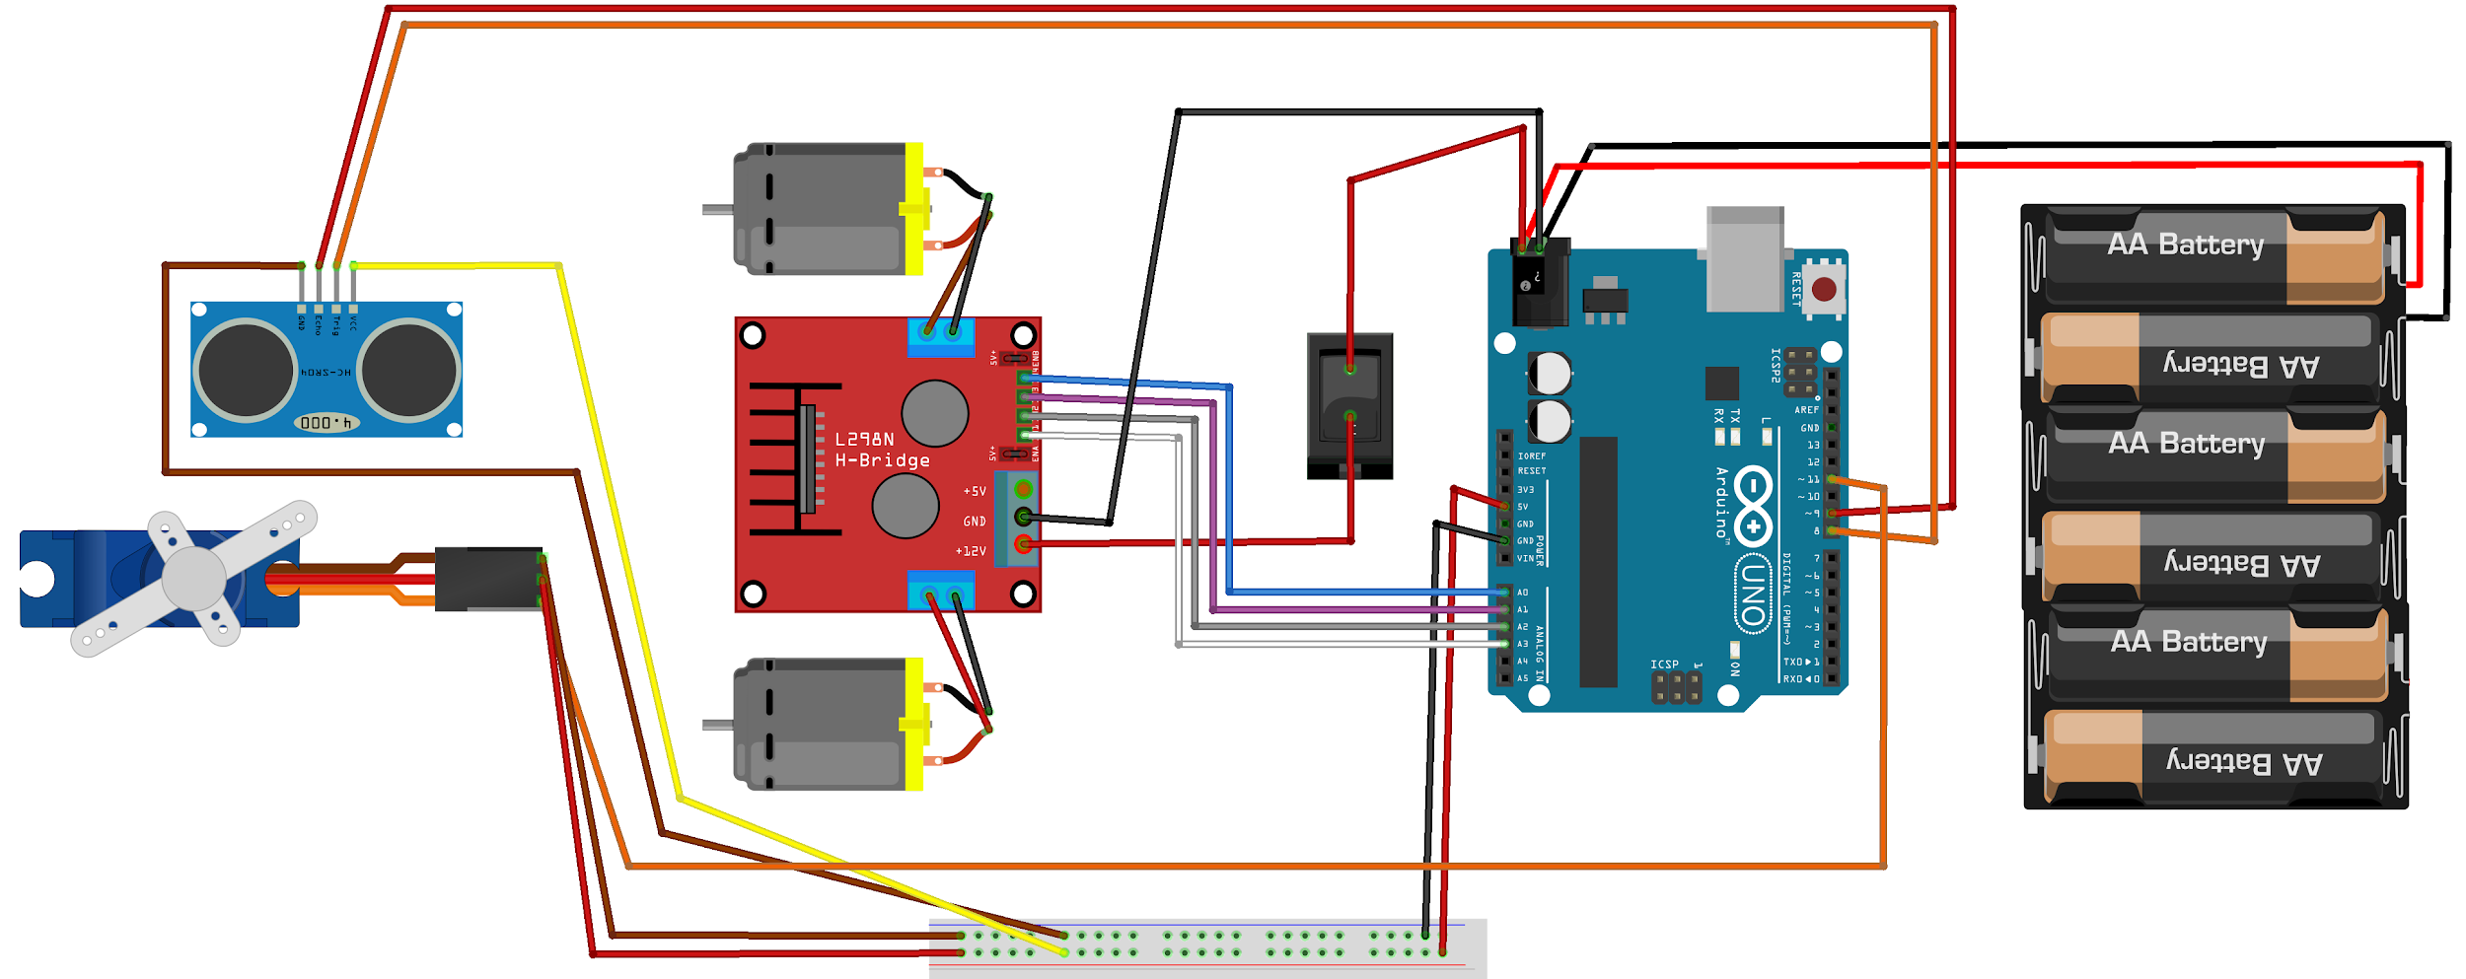

**Photos**

